Instruction Manual
Telescopic Fork Mounted Jibs

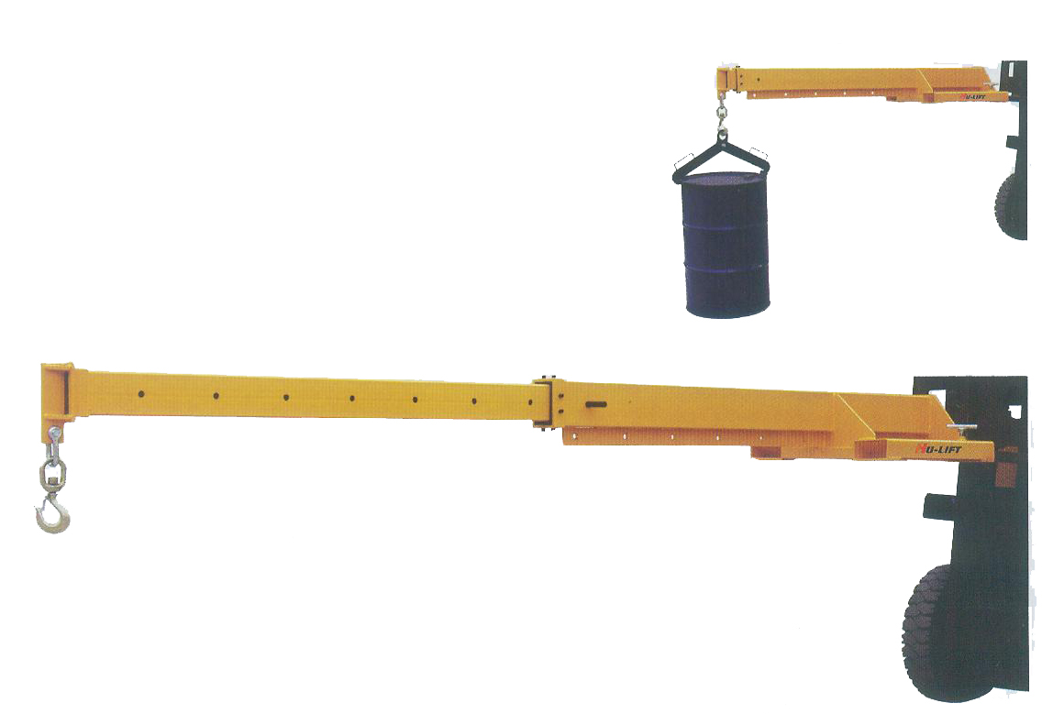

Note: The Owner/Operator must read carefully and understand
all the information presented here before operation.

Reva: 12/2007
cONTENTS

1. | Safety Precautions…………………………………….. | 2
2. | Receiving Instructions………………………………… | 2
3. | Installation Instructions………………………………. | 2
4. | Warranty…………………………………………………. | 3
5. | Before Operation………………………………………. | 3
6. | Operation………………………………………………… | 4
7. | Specification…………………………………………….. | 5
8. | Exploded View & Part List……………………………. | 6
Thank you for choosing our TELESCOPIC FORK MOUNTED jibS. For your safety and correct operation, please carefully read the manual before use.
NOTE: All of the information reported herein is based on data available at the time of printing. The factory reserves the right to modify its own products at any time without notice or incurring in any sanction. Please verify with the factory for possible updates.
1. SAFETY PRECAUTIONS
- Secure Telescopic Fork Mounted Jibs to fork with “T” Screw and safety chain.
- Never stand underneath lift device when in use.
- Be sure fork mast is tilted back toward driver.

2. RECEIVING INSTRUCTIONS
Every unit is thoroughly tested and inspected prior to shipment. However, it is possible that the unit may incur damage during transit. If damage is noticed, please inform the distributor at once.

3. INSTALLATION INSTRUCTIONS
Notice: Check the capacity of the forklift is enough to sustain the weight.
STEP1. Insert forks through fork pockets of boom so that the back side of boom is in contact with fork carriage of forklift.
STEP 2. Screw “T” screw to fork to make sure it is fastened with the fork, and attach safety chain to fork truck carriage.
STEP 3. Tilt fork carriage and mast back toward the driver so that boom does not slide off forks.
STEP 4. Make desired adjustments to boom length by sliding the inner extension tube in or out of main tube, and locking it down with infinite locking screw.

4. WARRANTY
This warranty does not cover normal wear of parts or damage resulting from any of the following: negligent use or misuse of the product, use or application contrary to installation instructions, or disassembly, repair or alteration by any person prior to authorization from a factory representative.

5. BEFORE OPERATION
- Ensure that forks of forklift are completely through boom fork pockets, and that the boom is against the fork uprights near the carriage of the forklift.
- Secure boom to forklift by “T” screw. Screw the “T” screw as tight as possible.
- Secure boom to forklift by safety chain around the carriage of the forklift. Pull the chain as tight as possible and lock chain to carriage utilizing the locking hook on either end of the chain.
- Extend the telescopic pipe to the desired distance and secure with the rod. Ensure the rod is locking the telescopic pipe is in place and it cannot move horizontally.
- Review boom capacity to ensure the boom can lift the desired load at the desired distance safely.
- Adjust the boom distance according the capacity and safety distance.
NEVER OVERLOAD THE FORKLIFT!
- Do not use the boom if it has been damaged.
- Tilt mast back toward driver. NEVER tilt mast top forward as boom may tent to slip off forks.

6. OPERATION
- Secure load to boom utilizing one or both front and rear hooks of the hook bar.
- Lift the load slowly, if the forklift begins to rise. The load is too heavy for the forklift, unattached the bundle and move the center of the load closer to the forklift. This may require pushing the telescoping pipe back into the larger pipe and locking into position through adjusting rod. Make sure all personnel are clear before attempting to lift load. If bundle does not raise evenly, re-center the “T” screw so the load remains parallel with the surface.
- Raise the load to transporting height, keeping load as close to the ground as possible.
- Transport the load to the desired location. Move slowly and avoid all bumps and inclines/declines. Ensure all personnel are clear of the area. If at any time the forklift begins to RISE, STOP, and adjust the center of the load as described.
- Raise /Lower the load into the desired position. Lower load slowly into place.
- Loosen the rod and un-attach safety chain from boom. Push telescoping boom back into larger pipe and secure with the rod.

7. SPECIFICATION
Length Positions (mm) | 755 | 985 | 1215 | 1445 | 1675 | 1905 | 2125
Capacity (kg) | 3000 | 2300 | 1865 | 1570 | 1355 | 1190 | 1065
Length Positions (mm) | 2355 | 2580 | 2810 | 3040 | 3270 | 3500
Capacity (kg) | 960 | 875 | 805 | 745 | 690 | 640
Notice: It is necessary to adjust the Rod according the capacity of load and boom distance.

8. EXPLODED VIEW & PART LIST

Item | Description | Qty | Remark
1 | “T” Screw | 2
2 | Boom | 1
3 | Pin | 1
4 | Rod | 1

